PROJECT REPORT ON

Chatbot

Submitted by: Name: Asutosh Sahu Roll No: 03BCA2514

Under the Guidance Of:
Mr. Swastik Ranjan Sahoo Department of Computer Application

October, 2026


DEPARTMENT OF COMPUTER APPLICATION

CREATIVE TECHNO COLLEGE BALUAKATA, SARADHAPUR, ANGUL

STUDENT DECLARATION

I hereby declare that the project report entitled “Chatbot” submitted in partial fulfillment of the requirement for the degree of BCA to Utkal University. This project is not submitted to any other university for the award of any other degree, fellowship or any other similar title of prizes.

Place: Baluakata, Saradhapur, Angul Name of Candidate: Asutosh Sahu

Date: Roll. No.: 03BCA2514



CERTIFICATE

This is to certify that Mr. ASUTOSH SAHU a student of BCA Second Semester bearing roll no: 03BCA2514 has successfully completed the Bonafide project entitled Chatbot. This project report is being accepted as the fulfillment of the requirement for the award degree of Bachelor of Computer Application at Creative Techno College under Utkal University, Odisha.

Signature Signature
(Head of the Department) Internal Guide

ACKNOWLEDGEMENT

I would like to express my sincere gratitude to everyone who contributed to the successful completion of this project.

I am especially thankful to my respected guide, Mr. Swastik Ranjan Sahoo, for his valuable guidance, continuous support, and encouragement throughout the project. His suggestions and expertise were invaluable in completing this work successfully.

I sincerely thank our Dean (Academic), Principal, Vice Principal, and all the teachers for their encouragement, guidance, and continuous support throughout our academic journey.

Finally, I express my gratitude to the faculty members and staff of Creative Techno College, Angul, as well as everyone who directly or indirectly contributed to the successful completion of this project.
Thank you.

ABSTRACT

The Chatbot Assistant is a web-based AI application built with a fast C++ backend server and a clean HTML, CSS, and JavaScript frontend. The project combines traditional rule-based programming with modern AI to answer user questions quickly and accurately.
The chatbot uses a smart Hybrid RAG (Retrieval-Augmented Generation) approach. When a user asks a question, the system first checks instant keyword rules and searches its verified local FAQ database using smart word-matching. If a matching answer is found, it responds instantly. If not, it safely passes the question and context to the cloud-based Groq AI model to generate a helpful response. If the internet goes down, the chatbot automatically falls back to offline mode so it never crashes.
Beyond simple text chat, the system can read and analyze uploaded TXT documents, Word files (.docx), and images using AI vision. Users can manage multiple chat sessions, edit previous questions, and export their chat history. The project also includes a password-protected Admin Panel to add, edit, or delete FAQs. To keep the app fast and safe, data is cached in computer memory (RAM) for instant speed, while security features protect against password guessing, harmful files, and web attacks.
Overall, this project demonstrates how to connect low-level C++ programming with modern web technologies and cloud AI to build a practical, secure, and responsive chatbot.

TABLE OF CONTENTS

No. | Topics | Page
1. | Introduction | 1-2
2. | Project Overview | 3-4
3. | Objective | 5
4. | Software & Hardware Requirements | 6
5. | Process | 7-10
6. | Source Code
7. | Output
8. | Conclusion
9. | Future Scope
10. | Reference

LIST OF FIGURES

Figure No. | Figure Name | Page No.
1. | Application Welcome Screen and System Status Banner
2.
3.
4.
5.
6.
7.
8.

INTRODUCTION

In today’s digital world, conversational systems and Artificial Intelligence (AI) are widely used to provide fast and interactive access to information. A chatbot is a program that communicates with users in natural language and can be developed using both rule-based techniques and modern AI. This project, titled "Chatbot Assistant," is a responsive web application built with a high-performance C++ backend server and a modern HTML, CSS, and JavaScript frontend.
The system answers questions using a smart Hybrid RAG (Retrieval-Augmented Generation) approach. When a user sends a message, the chatbot first checks instant keyword rules and searches its verified local FAQ database using text normalization and smart word-matching. If a matching answer is found, it replies instantly. If the question requires broader intelligence, it safely sends the question along with the relevant context to the cloud-based Groq AI model while preserving multi-turn conversation memory. If the internet connection drops, the system automatically falls back to offline mode to ensure it never stops working.
Beyond simple text messaging, the application supports multimodal file processing. It can extract and read text from TXT and Word (.docx) documents, as well as analyze images using AI computer vision for text recognition (OCR). The application also includes an authenticated Admin Panel to add, edit, or delete FAQs and export chat logs.
To keep the system fast and secure, conversation history and knowledge items are cached in computer memory (RAM) for sub-microsecond retrieval, while data changes are saved safely to disk using atomic file writing. Built-in security protections prevent password guessing, harmful file uploads, and web script injection. In summary, this project brings together core C++ programming, network communication, document parsing, web development, and modern AI capabilities into a fast, practical, and user-friendly system.

PROJECT OVERVIEW

The Chatbot Assistant is a fast, web-based conversational application built with a native C++ backend server and an interactive HTML, CSS, and JavaScript frontend. The application allows users to communicate with the chatbot using natural text and uploaded documents.
The chatbot works using a smart Hybrid RAG (Retrieval-Augmented Generation) system:
- When a user asks a question, the system first checks instant keyword rules and searches its verified local FAQ database (knowledge.json) using smart word-matching and synonym recognition.
- If an exact answer is found, it replies immediately without using the internet.
- If the question needs deeper intelligence, the chatbot safely sends the question along with the relevant context to the cloud-based Groq AI model (openai/gpt-oss-20b) to generate a clear, human-like response while remembering the conversation history.
- If the internet disconnects, the chatbot automatically switches to offline mode, ensuring it never crashes.
In addition to text chat, the system can read and analyze uploaded TXT files, Word documents (.docx), and images using AI computer vision for text recognition (OCR). The conversation system supports multiple chat sessions, question editing, and one-click chat export. An authenticated Admin Panel allows administrators to safely add, edit, or delete FAQs and monitor conversation logs.
To make the application fast and reliable, chat history and knowledge entries are cached directly in computer memory (RAM) for instant responses, while atomic file saving protects data from corruption. Built-in security protections prevent password guessing, malicious file uploads, and web script injection. In summary, this project combines C++ systems programming, file handling, network APIs, document parsing, web development, and modern AI into a complete and practical software application.

OBJECTIVES

- To develop a web-based conversational chatbot using a C++ backend with an HTML, CSS, and JavaScript interface.
- To process user queries using keyword-based rules, predefined FAQs, text normalization, and token-overlap matching.
- To integrate the Groq API to provide AI-generated responses for questions that cannot be answered by the local knowledge base.
- To maintain conversation history and support multiple conversation sessions using file handling.
- To develop a file-based knowledge system for storing and managing predefined questions and answers.
- To support TXT, DOCX, and image analysis, allowing users to upload files and obtain AI-based responses.
- To provide basic administrative controls for managing FAQ entries, viewing/exporting chat history, and clearing stored history.
- To implement basic security and error handling for safer and more reliable chatbot operation.

S/W & H/W Requirements

Software Requirements:
- Operating System: Windows 10 / Windows 11

- Programming Language: C++
- Frontend Technologies: HTML, CSS, JavaScript
- Compiler: GCC / MinGW-w64 through MSYS2
- C++ Libraries: cpp-httplib, nlohmann/json, libcurl

- AI Service: Groq API
- Web Browser: Google Chrome, Microsoft Edge, or any modern web browser
- Development Environment: MSYS2 with a C++ compiler supporting C++17 and the required libraries
- File Processing: Support for TXT, DOCX, and common image files
- Internet Connection: Required for Groq API-based AI responses

Hardware Requirements:
- Processor: Intel Core i3 or above
- RAM: Minimum 4 GB
- Storage: Minimum 500 MB free space for the project and required libraries

- Display: 1366 × 768 resolution or higher
- Input Devices: Keyboard and Mouse/Touchpad

PROCESS

The development and execution of the Chatbot Assistant project follow an organized, multi-step engineering lifecycle from environment configuration to final deployment and testing.
Step 1: Development Environment Setup
To build a modern C++17 application on Windows without bulky commercial IDEs, the open-source MSYS2 ecosystem was chosen:
- Install MSYS2:
- Download the MSYS2 64-bit installer from the official website: (https://www.msys2.org/).
- Complete the installation to the default directory C:\msys64.
2. Install the C++17 Compiler and Build Tools:
- Open the MSYS2 UCRT64 terminal and install the modern GCC compiler and supporting packages by running:
Bash:
pacman -Syu
pacman -S mingw-w64-ucrt-x86_64-gcc mingw-w64-ucrt-x86_64-curl
3. Configure System PATH:
- Add C:\msys64\ucrt64\bin to the Windows Environment Variables (System PATH) so that g++.exe and libcurl.dll are accessible from any terminal or Visual Studio Code.
4. Install Code Editor:
- Install Visual Studio Code from https://code.visualstudio.com/ along with the official C/C++ extension by Microsoft for syntax checking and project navigation.
Step 2: Acquiring Required Libraries and Headers
The project relies on clean, high-performance, open-source libraries:
- cpp-httplib (v0.18+):
  - Purpose: Provides a lightweight, multi-threaded C++ HTTP/HTTPS server and client in a single header file.
  - Source: Download httplib.h from GitHub (https://github.com/yhirose/cpp-httplib) and place it in the project Source/ directory.
- nlohmann/json (v3.11+):
  - Purpose: Industry-standard, header-only JSON library for parsing and serializing API requests and configuration files in C++.
  - Source: Download json.hpp from GitHub (https://github.com/nlohmann/json) and place it in Source/.
- libcurl:
  - Purpose: A multiprotocol file transfer library used by the C++ backend to establish secure HTTPS connections with cloud AI APIs.
  - Source: Installed natively via MSYS2 (libcurl-4.dll and header <curl/curl.h>).
- Frontend Client-Side Libraries:
  - marked.js: Parses AI Markdown responses into clean HTML formatted text.
  - highlight.js: Provides real-time code syntax highlighting with copy buttons.
  - DOMPurify: Sanitizes all generated HTML prior to DOM insertion, neutralizing Cross-Site Scripting (XSS).
Step 3: Obtaining the Groq Cloud AI API Key
The chatbot utilizes the Groq Cloud platform for high-speed Large Language Model (LLM) and Computer Vision inference:
- Create an Account:
  - Visit the official Groq Console: https://console.groq.com/.
  - Sign up for a free developer account using your Google, GitHub, or email credentials.
- Generate the Secret API Key:
  - Navigate to the API Keys section in the left navigation sidebar.
  - Click on the Create API Key button.
  - Name the key (e.g., Chatbot-Assistant-Key) and click Submit.
  - Copy the generated key (formatted as gsk_...).
- Configure Secrets Securely:
  - In the project directory, create a hidden .env file to store credentials:
env
GROQ_API_KEY=gsk_your_generated_groq_api_key_here
ADMIN_PASSWORD=your_secure_admin_password
  - Security Note: Secrets are loaded exclusively into backend memory and are never exposed or transmitted to client browsers.
Step 4: Directory Structure and Workspace Setup
The project is organized in a decoupled client-server directory layout:
ChatBot/
├── Source/
│ ├── chatbot.cpp # C++17 Multi-Threaded HTTP Server & RAG Engine
│ ├── httplib.h # Single-header HTTP server library
│ ├── json.hpp # Single-header nlohmann JSON library
│ ├── index.html # Web application UI (Single Page Application)
│ ├── style.css # Nordic responsive styling and theme tokens
│ ├── script.js # Client-side state manager and DOM controller
│ ├── knowledge.json # Verified FAQ institutional database
│ ├── chat_history.json # Persistent conversation session logs
│ └── .env # API keys and admin security credentials
├── Docs/
│ └── Project Report.docx # Academic project report documentation
└── README.md # Quick-start instructions and architecture overview

Step 5: Backend Engine Implementation (C++17)
The backend daemon was developed in Source/chatbot.cpp implementing the following core modules:
- Cascading 4-Tier Hybrid RAG Pipeline:
  - Tier 1: Instant keyword matching for greetings, farewells, and courtesy phrases ($<0.1\text{ms}$).
  - Tier 2: Custom multi-signal knowledge retriever incorporating text normalization, 40+ canonical synonyms, stop-word elimination, and bidirectional token-overlap scoring.
  - Tier 3: Context-augmented prompt construction injecting retrieved facts and the last 10 conversation turns into the Groq API (openai/gpt-oss-20b) via libcurl.
  - Tier 4: Autonomous offline fallback serving verified local answers if internet connectivity fails.
- Dual-Tier Write-Through In-Memory Caching:
  - Active FAQs and chat histories are hydrated into RAM vectors (g_cachedKnowledge, g_cachedHistory) guarded by std::lock_guard<std::mutex>.
  - Read operations achieve sub-microsecond ($<1μ\text{s}$) latency.
  - Write operations use atomic temporary file swapping (.tmp $→$.json via std::rename) to guarantee crash resilience.
- Multimodal Document and Vision Processing:
  - Microsoft Word (.docx) files are parsed by decompressing the underlying PK ZIP format and extracting paragraph nodes (<w:p>) from word/document.xml.
  - Plain text (.txt) documents are streamed directly into memory.
  - Image files (.png, .jpg, .jpeg, .webp, .gif, .bmp) are base64-encoded and sent to Groq Vision (qwen/qwen3.8-27b) for OCR and visual analysis.
- Hardened Security Perimeter:
  - Constant-time bitwise XOR password comparison (timingSafeCompare) to prevent timing side-channel attacks on /api/admin/login.
  - File path traversal sanitization (sanitizeFilename) stripping .., slashes, and reserved characters.
  - HTTP CORS preflight request handling (OPTIONS /.*).
  - Brute-force IP rate limiting (locks an IP address for 15 minutes after 5 failed attempts).

Step 6: Frontend UI and Client-Side Engineering
The user interface was built in index.html, style.css, and script.js with the following features:
- Nordic-Themed Responsive Layout: Mobile-friendly design with light/dark theme switching and clean typography.
- Interactive Message Controls: Inline question editing (allowing users to edit any previous query and automatically prune subsequent branch turns), response regeneration, and one-click code block copying.
- Responsive Chat Controls: One-click code copying, inline question editing with history branch truncation, and response regeneration.
- Admin Panel: Password-protected modal interface to Create, Read, Update, and Delete (CRUD) FAQ entries and export conversation logs to CSV or JSON.

Step 7: Compilation and Execution
To compile the C++ server into a standalone Windows binary:
- Compilation Command: Open a terminal in the project directory and execute:
bash
g++ -std=c++17 -O2 -I. -static-libgcc -static-libstdc++ Source/chatbot.cpp -o chatbot_updated.exe -lcurl -lws2_32 -lwinpthread
Explanation of Flags:
  - -std=c++17: Enables modern C++17 language features.
  - -O2: Applies high-performance compiler optimizations.
  - -static-libgcc -static-libstdc++: Bundles standard libraries into the binary for maximum portability.
  - -lcurl -lws2_32 -lwinpthread: Links the cURL network library, Windows Sockets (WinSock2), and multi-threading primitives.
- Run the Server:
Bash:
./chatbot_updated.exe
The terminal will display:
text
========================================
Chatbot Assistant C++ Server
========================================
Starting server...
Server successfully bound to port 8080.
Open: http://127.0.0.1:8080
3. Access the Application: Open any modern web browser (Chrome, Edge, Firefox) and navigate to:
text
http://127.0.0.1:8080
Step 8: System Verification & Testing
Comprehensive manual and functional tests were conducted:
- Instant Response Test: Verified that greetings ("Hello", "Good morning") return hardcoded reflex responses in $<1\text{ms}$.
- Knowledge Retrieval Test: Queried institutional questions ("What are the BCA course fees?") and verified accurate scoring and answer retrieval.
- RAG & Cloud AI Test: Asked complex, open-ended technical questions and verified grounded, formatted responses from the Groq API.
- Offline Reliability Test: Disabled the network connection and verified that the chatbot automatically served verified offline FAQs without throwing application crashes.
- File Upload Test: Uploaded sample .txt, .docx, and screenshot images to confirm accurate text extraction and Vision AI OCR.
- Security Audit: Tested password rate limiting by attempting 5 invalid admin logins; verified that the server correctly enforced a 15-minute IP lockout.

SOURCE CODE

OUTPUT

Figure 1: Application Welcome Screen and System Status Banner
Description: Figure 1 illustrates the initial entry welcome screen of the Chatbot Assistant web application. It features a centered Nordic modal with a system greeting, a quick-action "Start Chatting →" button, and an operational status indicator showing real-time connectivity (Online), AI engine specification (Powered by Groq AI), architecture badge (Hybrid RAG), and client data privacy notice.

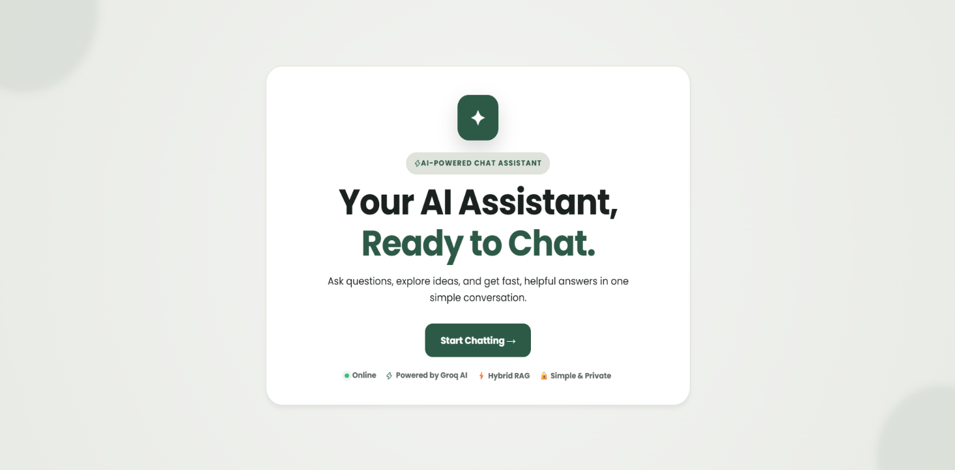

Figure 2: Primary Chat Interface and Navigation Dashboard
Description: Figure 2 displays the main user interface dashboard upon entering the chat workspace. It comprises:
- Left Navigation Sidebar: Housing links for Home / Chat, Conversation History, Knowledge Base (Admin), About Us, and Dark Mode toggle.
- Header Bar: Containing chatbot status info and action controls (clear chat and exit application).
- Chat Stream: Showing initial assistant greetings with timestamps.
- Prompt Controls: Featuring rapid-inquiry suggestion pills (What is C++?, What is HTML?, etc.), the multimodal file attachment button (for TXT, DOCX, and images), and the message input bar.

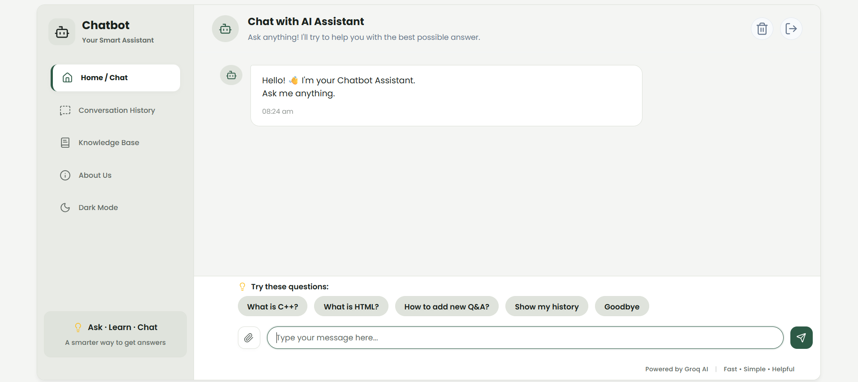

Figure 3: Hybrid RAG Conversational Response and User Action Controls
Description: Figure 3 demonstrates an active conversational turn within the Chatbot Assistant. When the user asks "What is C++?", the system executes the multi-signal knowledge retriever, matches institutional curriculum data from knowledge.json, and synthesizes a structured Markdown response with key technical points and college context. The interface also highlights the interactive user controls—including the Edit (pencil) button for dynamic question updating and the Copy button, along with exact turn timestamps.

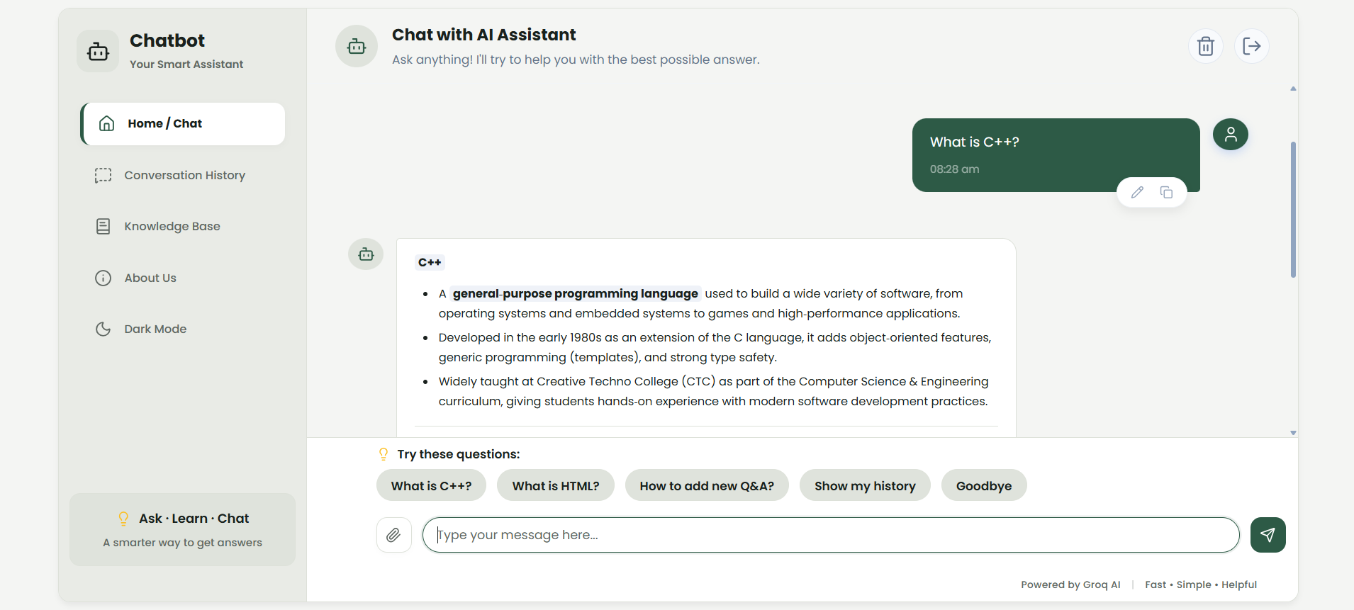

CONCLUSION

The Chatbot Assistant project successfully demonstrates how to build a fast, secure, and modern conversational AI platform using a C++ backend server and a responsive HTML, CSS, and JavaScript frontend. By using C++17, the application achieves high performance and minimal memory usage without needing heavy runtime environments like Python or Node.js.
The core strength of the project is its Hybrid RAG (Retrieval-Augmented Generation) system. The chatbot combines instant keyword rules and a smart in-memory FAQ database with the cloud-based Groq AI model. This ensures that college-specific questions are answered instantly with verified facts, while general questions receive smart, natural AI responses. If the internet goes down, the chatbot automatically switches to offline mode so it never crashes.
In addition to text chat, the system successfully processes TXT files, Word documents (.docx), and images using AI computer vision for text recognition (OCR). It also provides dynamic question editing, response regeneration... and a password-protected Admin Panel to manage FAQs and export chat history. Data is cached in computer memory (RAM) for instant speed, while built-in security protects against password guessing, harmful file uploads, and web attacks.
Overall, this project brought together low-level systems programming, web technologies, document parsing, network APIs, and modern generative AI. All project objectives were successfully achieved.

FUTURE SCOPE

While the Chatbot Assistant is already fast, secure, and fully functional, it can be expanded in the future with the following advanced features:
- Fully Offline Local AI: Integrate an embedded AI engine (like llama.cpp) to run small AI models directly on the computer without needing any internet connection or cloud API keys.
- Semantic Vector Search: Add AI vector embeddings so the chatbot can understand the deeper meaning and context of questions beyond keyword and synonym matching.
- Improved Knowledge Base: Expand the FAQ and knowledge system with a larger and more structured database.
- Database Integration (SQLite / PostgreSQL): Upgrade from JSON file storage to a relational database like SQLite to easily manage millions of chat records across multiple servers
- PDF and Spreadsheet Support: Add built-in support for reading PDF files and Excel spreadsheets (.xlsx) for automated data summaries.
- Individual Student Logins: Introduce student and teacher user accounts with personal login credentials and private chat histories.
- Regional Language Support: Add multilingual translation to allow users to ask questions in regional languages such as Odia and Hindi.

REFERENCES

- C++ Documentation – cppreference.com
https://en.cppreference.com/
- cpp-httplib – C++ HTTP/HTTPS Server and Client Library
https://github.com/yhirose/cpp-httplib
- nlohmann/json – JSON for Modern C++
https://github.com/nlohmann/json
- libcurl Documentation – Client URL Library
https://curl.se/libcurl/
- Groq API Documentation
https://console.groq.com/docs.
- MDN Web Docs – HTML, CSS, JavaScript and Web APIs
https://developer.mozilla.org/en-US/
- DOMPurify – Client-Side HTML XSS Sanitization
https://github.com/cure53/DOMPurify
- Retrieval-Augmented Generation (RAG) Architecture Overview
https://arxiv.org/abs/2005.11401

